Lab - Researching RFCs

1. Objectives

Part 1: RFC Editor

* Navigate to the RFC Editor.
* Search for RFCs using keywords.
* Find RFCs by status.
* Search for humorous RFCs.

Part 2: Publishing RFCs

1. Background / Scenario

Request for Comments (RFCs) were created by Steve Crocker to help record notes on development of Advanced Research Projects Agency Network (ARPANET) in 1969 and eventually evolved into an official collection of memorandum that describes topics that are mainly related to the Internet and the TCP/IP protocol suite. Today the RFCs are managed by the IETF. There are currently over 6,000 RFCs, and the complete list is available at <http://www.ietf.org/download/rfc-index.txt>.

In this lab, you will learn how an RFC is published today by IETF. Additionally, you will also identify a few well-known RFCs that are used in your network. You can also find a few non-technical RFCs that can provide information or engineering humor.

1. Required Resources

Device with Internet access

1. RFC Editor

RFCs started as a collection of memorandum on the development of the first Internet (ARPANET). In this collection, only a few RFCs are considered as Internet standards. Most of the RFCs describe experimental protocols. Some of the RFCs are only informational. The main purpose of RFCs is to stimulate comment and discussion.

* 1. Navigate to the RFC Editor.

All the published RFCs are available for access at <http://www.rfc-editor.org>. The RFC Editor is an RFC repository maintained by the IETF.

At the top banner of this page, you can click any of the links, and these links direct you to the different searches, databases, and information. A link to **IETF HOME** is also included within this blue banner.

After an RFC is located, you have access to the full text of the document.

* 1. Search for RFCs using keywords.
     1. Open a browser and navigate to <http://www.rfc-editor.org>. On the RFC Editor Homepage, you can search and retrieve RFCs and other information related to the Internet. In the **Finding and Retrieving RFCs, etc.** pane, these links can help you search for RFCs using different methods. Clicking **Search for an RFC and its meta-data** link displays a list of RFCs after inputting your search parameters, such as number, author, title, or keyword.

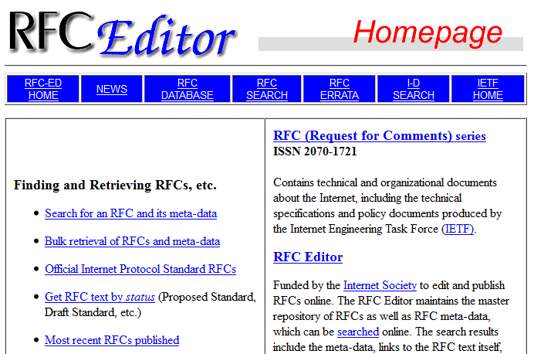

* + 1. Input the word, **pop**, to search for POP. Click **Search** to continue.

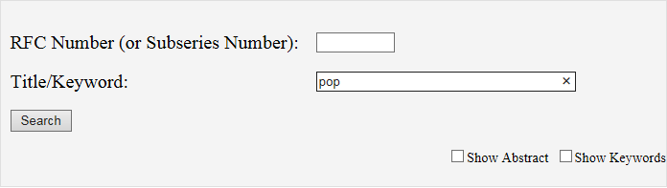

Look for **Post Office Protocol – Version 3** in the list. The associated RFC number is **RFC 1939**. This RFC is also an Internet standard, as indicated by the STD number in the **Number** column.

After an RFC is published and assigned a number, it cannot be changed and the RFC number is never used again for a newer RFC. For example, in the **More Info** column, RFC 1939 has made the previous RFC 1725 obsolete. The information in RFC 1725 has not been modified, but it has been replaced with the information from RFC 1939. RFC 1939 has been updated by RFC 1957, RFC 2449, and RFC 6186, as indicated in the **More Info** column. If you click any of these links, the full text of the RFC displays.

Refer to the **Status** column and locate the **Proposed Standard** status. They may be technically sound, but require further testing and validation.

Refer to the **Status** column and locate the **Informational** status. Informational RFCs can be anything from technical to humorous. For example, RFC 0035 (Network Meeting) provides an insight into the development of a network protocol in the early days of the Internet.

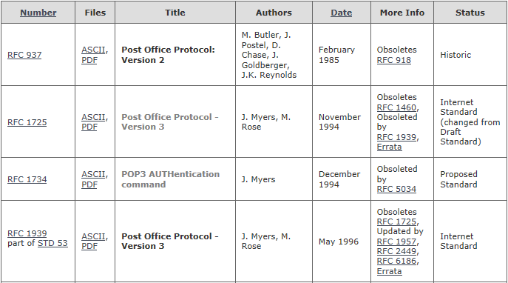

* 1. Find RFCs by status.

To find a list of RFCs that are either Internet Standards (STD) or by their status, perform the following tasks:

* + 1. Navigate back to the RFC Editor Homepage.
    2. Click the **Official Internet Protocol Standard RFCs** link in the left column. You will find a list of official standard RFCs followed by proposed standards. Each RFC link leads to the full RFC text.

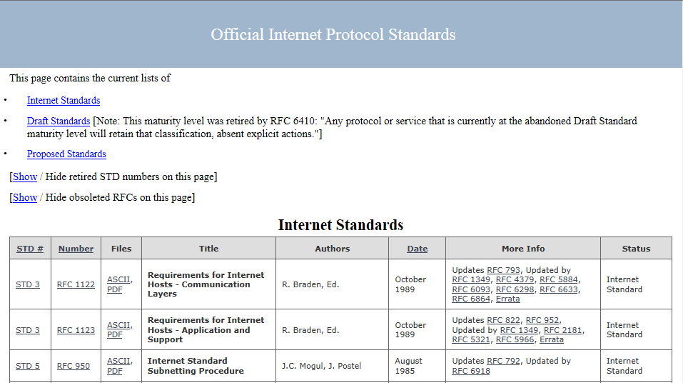

* 1. Search for humorous RFCs.

Engineering humor can also be found in the RFCs, such as RFC 1300 (Remembrances of Things Past). An Internet search engine can be used to find information on RFCs.

* + 1. Search the Internet for “engineering humor rfc” to see more examples of whimsical RFCs. What did you find?

____________________________________________________________________________________

* + 1. Search for RFC 2795. What is the subject of this RFC? _______________________________________

What company does the author of this RFC work for? _________________________________________

1. Publishing RFCs

The late Dr. Jonathan Postel maintained and managed the archiving of RFCs for 28 years (RFC 2468). Today, RFCs are a collection of documents published and managed by IETF. IETF is a large, open, international community of network designers, operators, vendors, and researchers related to the Internet and the Internet protocol suite.

Anyone can submit a proposal to the RFC Editor for possible publication. The proposal is initially published as an Internet-Draft (I-D). After review by the community and if it is approved by an RFC Editor, it will enter the same publishing process as IETF submission. For more details regarding independent submission, see <http://www.rfc-editor.org/indsubs.html>.

For proposals that may become Internet Standard or Best Current Practice and some Experimental or Informational RFCs, these submissions are published as Internet-Drafts. The Internet-Drafts are made available for informal review and comments. The Internet-Drafts have no formal status, and they are subject to change or removal at any time. They can be found at <http://www.rfc-editor.org/>.

* + 1. Navigate to [http://www.rfc-editor.org](http://www.rfc-editor.org/).
    2. Click **I-D SEARCH** at the top of the Homepage. Under the heading **Search Internet-Drafts and RFCs**, input **6man** into the **Name/number/title:** field. Click **Search** to continue. This will display a list of the current Internet-Drafts related to 6man.

The list of results provides links to the full text of the I-Ds and other useful information. As an example, **6man** is a Working Group that submitted multiple drafts. To find out more information about this Working Group, click **Active WGs** on the left panel under the heading Working Groups.

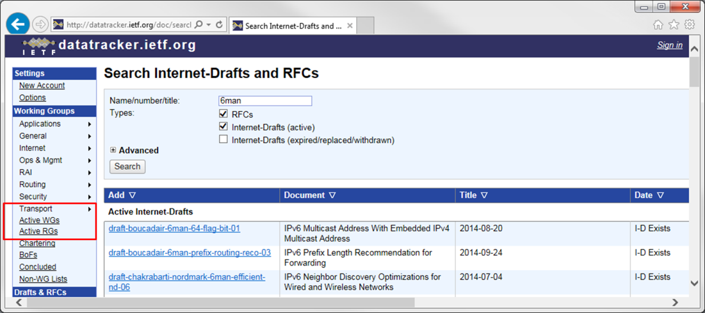

The Active IETF Working Groups page displays. The IETF Working Group’s (WG) primary function is to develop IETF specifications and guidelines. Many of these specifications and guidelines are intended to become standards or recommendations. By scrolling the page, you see a list of Active Working Groups in different development areas for technology related to networking. The **6man** Working Group can be found listed in the Internet Area. This working group is responsible for maintenance and advancement of the IPv6 protocol specifications and addressing architecture.

* + 1. Click **6man** to view the complete list of current proposals and other information for this Working Group.

After the I-D has received significant community review and is considered useful, stable, and well-understood by the community, it should become a Proposed Standard. The full text of the Proposed Standard can be found by searching in the [RFC-Editor](http://www.rfc-editor.org/). The Proposed Standard may become an Internet Standard after significant implementation and successful operational experience.

**Note**: Only a few RFCs published by IETF will become Internet standards.

1. Reflection
   1. Why are RFCs important for Internet standards and history?

_______________________________________________________________________________________

_______________________________________________________________________________________

_______________________________________________________________________________________

* 1. What are the advantages of RFCs as a collaborative effort?

_______________________________________________________________________________________

_______________________________________________________________________________________

_______________________________________________________________________________________